Lean Canvas Questionnaire

The Lean Canvas is a script of questions organized by topic that brings clarity to a project at the start of the development lifecycle. It helps teams create high-quality products that users will adopt. Here’s what you do:

- Schedule a meeting with all key stakeholders and the product team.
- CRITICAL: Turn transcription ON during your scheduled meeting so Copilot can take notes.
- Take your own notes as backup—because tech hiccups happen.
- During the meeting ask your stakeholders the questions below. Don’t go deep; just capture clear answers to every section.
- Questions that cannot be answered pose risks to your project and need to be researched and reviewed subsequent meetings.
If you need more details, visit Creating a Minimum Lovable Product with Lean Canvas.

Project Summary:
- Briefly summarize the project.

Less duplication with QRA. Make it complimentary. North Star – duplicate the most important elements from QRA. Alignment high priority. Thinner layer that’s pertinent for people to get.

John – Caid and mktplace, we’ve identified higher weighted measures. Those should be visualized.

Medicare is STARs only.

Can you hyperlink QRA here? John Z likes this idea. QRA is the tool for quality folks to use, and will continue.

Dan wants to see targets of focus. Current landing page in PPA, don’t get the action. QRA doesn’t show sense of action either.

QPA gets into weight , get to next star threshold. Clinical, preventative score.
PE convo is “you can do better with scheduling…. Diabetics, utilization, etc…”. Fix the HBR pop management.

JL -- New page in PPA – diabetic metrics, APV, it’s more thought making quality… Quality highlights (not summary)

See the things – measures that matters, unique to market, this is what surfaces for each practice. Want to customize logic by provider. This sounds difficult.

AI summarizing for Members. We need to think about this in future. Point toward dynamic.

JL suggests You have X Members with Quality less than 3, X less than 2, …etc…. Quality is only HEDIS and Pharmacy. Very actionable for providers.

Flynn – histography, click cohorts, show top 5 measures. Click member cohort, filter measure categorical list to driving it. Then key outcome metrics HBR or RACCY of those members. PE says “we started hbr, raccy… look how it overlaps with Quality. It’s the same members driving both. HBR is 110% of these members”. It reinforces why provider should go after Quality stuff.

John Z likes Flynn’s ideas. He doesn’t want quality view in isolation from QRA. Bring in and connect dots… PE folks are not Quality experts. Help them reinforce. Risk adjust ment for this group, HBR for this group. Here’s the overlap. HBR, RACCY, RISK, Quality

Find ways to make the right hand stuff mor ehigh level, focus on member tie on, what’s spread on mem impacting quality, tie it to what PE owned stuff (HBR, pop management utilization, etc.). Don’t duplicate. Make it clearly a PE conversation.

Dan wants this landing page – ‘for this practice, these are the measures that matter’. Across lines of business. These feel very custom / bespoke. Are we able to do that? Derek says QDH has some flags. P4P might not be perfect state to state. John Z’s team has MVP reports… one state has withhold around 6 or 7 things. When you land on a practice, the general list… but “here’s your state withhold measures”. Derek says “the list is somewhere”

Scores, then “here’s what matters to you…top drivers” then member list spread (distribution). Cohorts. Tie into “this is your HBR impact”.

JL – no we can’t get quality score at member level. But we can get approximation.

For John – Make connection to HBR, but not duplicate.

Listent to graph idea Flynn had -- If all gaps closed for members, etc…

Dan -- Missing from QRA page -- ?

JL - If we click on Access Medical, what can we show from member level.
Derek – Qualiy means 1-5 for collection of people 10 people in measure, 50% in cutpoints. Etc… need a collection of people – index and tier in QRA.
Weighted sum of open gaps – it’s in QDH now. Exists and gets used.

If we can get data assets,
Visualization has to “pop”.
Flynn likes PPA provider – likes histogram. Click a bar and see the cohort.

Maybe “Outcome potential” area. “If you did this, you would have that.”

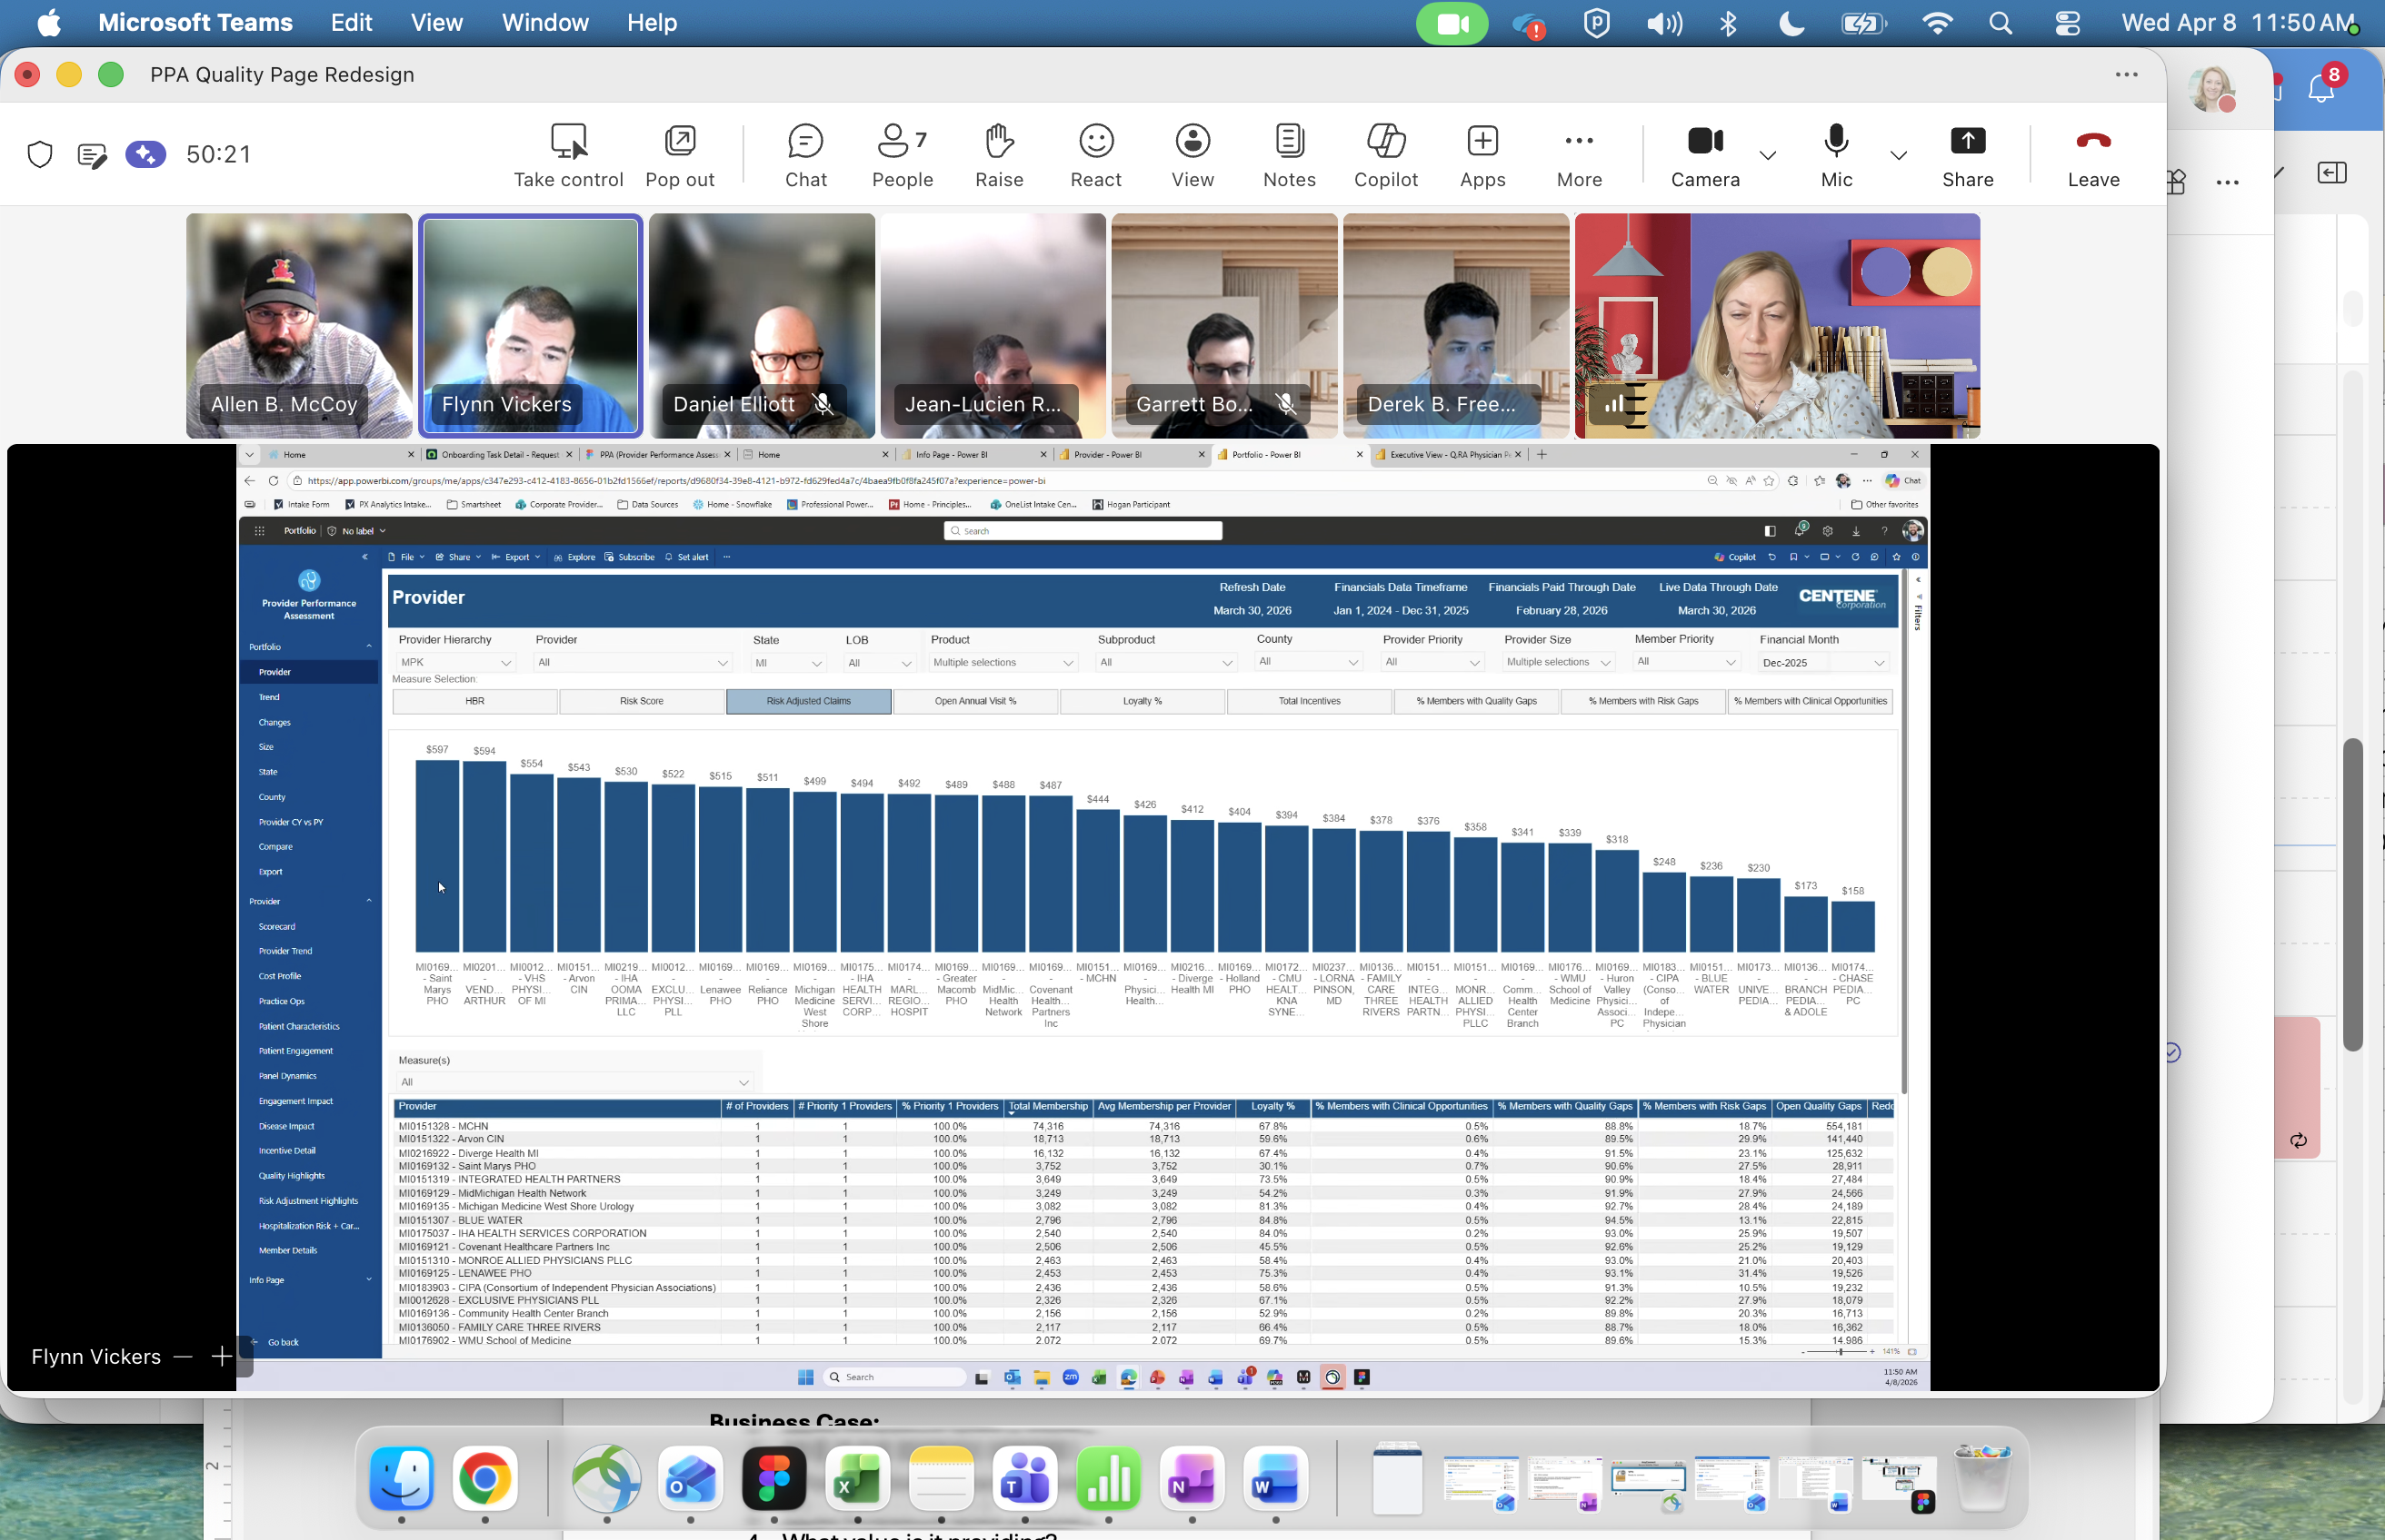

- Does the stakeholder have any specific wishes for the solution?

Business Case:
- Why is the solution needed?
- What problems does it solve?
- Why is it important?
- What value is it providing?

Existing Solutions:
- Do similar solutions currently exist? If so:
- Why are they insufficient?
- What are the limitations of these solutions?
- Who maintains them (a team, vendor, other)?

Data Details:
- Where is the data located?
- What is the source of truth?
- How is data fed into the source?
- What transformations are behind it?
- Does the data include PHI / PII?

Data Frequency:
- How frequently is data refreshed now?
- What is the required refresh rate? Example:
- Operational (daily or near real time)
- Exec / KPI metrics (monthly, quarterly, yearly)
- What level of data detail is necessary?
- What period of time should data show (last 3 months, 3 quarters, YTD)?

End Users:
- Who are hands-on user groups that will use this solution (execs, managers, associates)?
- What are the users’ roles at Centene and where do they focus their attention?
- Is row-level security required, and how will it be applied?

Use Cases:
- What are use cases for each user type; Which use cases are most important?
- What information or stories will the solution offer for each user type?
- What questions will users ask the data?
- What actions will users take based on the data?

Solutions / Visuals:
- How will users consume the data in our solution (via a dashboard, extract, etc.)
- What stories can we tell?
- What visualizations can we show?

Success Metrics:
- How will we measure the success of the product (NPS/CSAT, usage, time on task, etc.)?
- If success metrics are not being met, how will we identify the issue?

AI Prompts:
- What insights do users need that might be served by Copilot AI?
- What potential prompts could work with our data set?
- How comfortable is our user base on using Copilot AI?
- How can we make them more comfortable?

Post-Launch Adoption:
- How will we market this tool to the users we’ve identified?
- How will we train users to utilize the product?
- Will you publish on Centene Data & Analytics Hub?
- Formal learning path?
- Will you have a dedicated Teams channel?

Support & Misc:
- How will we support the project in the long term?
- How will enhancements be handled?
- What other gaps in knowledge exist that were not captured on previous boxes?

